
HASS  Managing Australian communities | Year 5 | Unit 2
Assessment task — Managing Australian communities: Model response
Task
Purpose of assessment: To identify how legal and environmental issues in Australian communities can be managed.
Instructions
Part A: Describing roles
Students will:
- describe the roles of different people in Australia’s legal system.
Part B: Sorting, recording and representing
Students will:
- identify the effects of these interconnections on the characteristics of place and environments
- sort, record and represent data in different formats, including large-scale maps, using basic conventions.
Part C: Proposing action
Students will:
- sequence information about selected phenomena in chronological order
- independently propose action
- describe the possible effects of their proposed action
- present their ideas, findings and conclusions in a range of communication forms using discipline-specific terms and appropriate conventions.
Part A: Describing roles
- Answer true or false.
- A responsibility of the Australian police is to keep the peace and maintain order in a community. | T F
- Each state and territory has its own police force that deals with crimes. | T F
- State and territory police investigate illegal immigration and transportation of goods. | T F
- It is a responsibility of the police to decide whether a person is guilty. | T F
- State and territory police officers enforce traffic laws. | T F
- Describe each person’s role. Answers are examples. Student responses will vary.
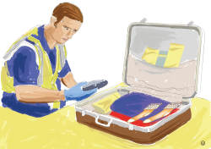 | Customs officer  - Manage the security of the Australian border.  - Ensure that the movement of people and goods across international borders is lawful.  - Protect the safety, security and commercial interests of Australia.
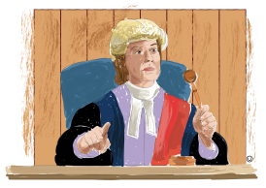 | Judge  - Interpret the law.  - Administer justice according to the law.  - Control how hearings and trials unfold in courtrooms.
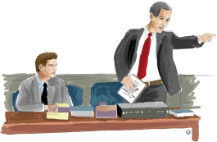 | Lawyer  - Understand the laws governing a country.  - Be confidential about the details of a client’s case.  - Provide legal advice to clients.

Part B: Sorting, recording and representing
Areas on the Little Keelington town map (assessment task Managing Australian Communities: Source) have been shaded to identify their zone.
- Use the information on the town map to complete the legend.
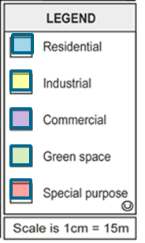
- Shade another area on the town map to represent the zone it is located in.

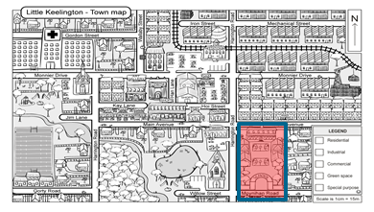
- Choose the correct word in each statement:
The (residential / commercial) zone limits the construction of high-rise buildings.
The (industrial / commercial) zone allows for services such as shopping centres.
The (special purpose / industrial) zone is usually located away from residential areas.
The (green space / special purpose) zone is an open area of land for recreation.
- How have the zones in Little Keelington been planned to meet the needs of people?
In Little Keelington, the commercial zone is located in the middle of the town so all people have easy access to shops and services. The green space zones are positioned throughout the town providing open spaces with grass and trees for people to enjoy at any time of the day.

Part C: Proposing action
- Which strategy would be most effective in preparation for an extreme natural event?
- Make it compulsory for all households to register an emergency plan with the local emergency services (police/fire and rescue).
- Explain why this is an effective preparation strategy.
The compulsory emergency plan is the better strategy because it means that people will know what to do if an event occurs. The early warning may reach a lot of people and give them some time to decide what to do, but an emergency plan will help people to find each other, contact each other or to have access to essential supplies after the event. It is also a low-cost strategy.
- What would you include in an emergency kit?
An emergency kit should contain a radio, first aid kit, torch, medicines, water and some food.
- How would these items be useful in an emergency?
A radio provides updates about the management of the extreme natural event such as road closures, plus details such as where evacuation centres are located. A radio can be used if the power is cut due to the extreme event and a torch will also be necessary if this occurs. The medicines, water and food will be needed for the people during and after the extreme event.
- Sequence ways a community could prepare, manage and respond to a flood.
Flood events sequence

Preparing | Build houses on higher ground
 | Community awareness publications
 | Releasing water from dams
Managing | Early warnings for evacuation
 | Evacuation centres set up
 | Radio announcements and text message alerts
Responding | Community volunteers respond
 | Organised clean up-collection points
 | Repair damage

